Sligo
Family Resource Centre

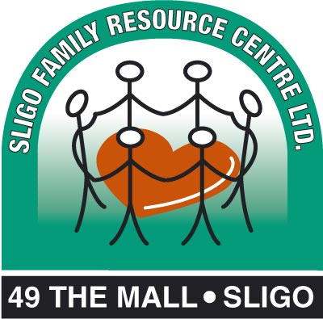

Annual Report 2013

Introduction
Sligo Family Resource Centre (FRC) has been in operation since 1995. We are based at 49 The Mall, Sligo. Our Centre is one of 106 national Centres under the FSA Programme and our unique mission is to:
“serve all families without discrimination, in a warm, caring and open environment. We continually strive to identify ongoing and changing needs and to respond to them in a positive fashion. We aim to provide support, information and development courses of the highest standard to families in the Sligo area.”

The Centre is currently at the end of the Sligo FRC three year strategic plan 2011-2014, designed to achieve the following objectives:
- To consolidate the existing work of the FRC;
- To be inclusive of families in the area experiencing isolation, disadvantage and poverty;
- To be inclusive of families from minority groups including Travellers , refugees and asylum seekers, migrants, members of new communities, people with disabilities, lesbian, gay bisexual and transgender (LGBT);
- To provide relevant supports and services for grandparents, parents and their children.

We provide services to meet these objectives through a number of key strategies:
- Information and Services;
- Community based education, training and social integration opportunities;
- Home and Family Support including Footprints Drop-in Creche;
- Services to Adults with a Learning Disability Living in the Community;
- Representation and inter-agency Initiatives;
- Training through CE Scheme.

2013 was a busy year at Sligo Family Resource Centre with a range of services and programmes to respond to the changing needs of families, while at the same time managing contracting budgets and increasing fundraising activity. The Centre itself is a hive of activity and we have an extensive family support programme based in families’ homes and other activities supported in Caltragh. We continue to build good working relationships with other voluntary and statutory agencies in Sligo in order to create more efficient and effective responses to need in the face of diminishing resources.

Significant national policy changes impacting Family Resource Centres nationally took place in 2012. The Family Support Agency began to merge with the programmes it administers to form the new Child and Family Agency on 01 January 2014. It is a period of immense change and uncertainty, but we are confident our work will continue to be funded and FRCs nationally will maintain their role as key players in community based family support services.

West Training support agency continued to work with us in 2013 and we are grateful for the expertise and support of Mary Seale and Morgan Mee during the year.

A statistical analysis of every aspect of Sligo FRC’s work is made through the FRC’s SPEAK recording system annually each year. This annual report is intended to give you a flavour of the various events and activities we engage in in order to serve families in Sligo.

Information and Services
Sligo FRC welcomes any member of the community to avail of its programmes and services and/or to find out more about other services or opportunities in Sligo.

Information was provided in 2013 through a selection of leaflets, fliers, posters and websites at the front office. Staff can respond to a range of queries through the bank of knowledge built up in “the front office”. Administrative support such as design work, photocopying and printing, a parenting book loan service etc is also available at the Centre.

The Family Room continues to provide respite for busy parents and carers who can drop in to comfortable facilities for a bit of time out and a cup of tea. Children can play or read and adults can meet to chat or feed a baby. It is also the location of our Toy Library which continues to offer parent-members use of toys they may not have at home for a lifetime membership of €5.00. On the bright sunny days when they come, the Outdoor Garden offers lovely play opportunities and a good meeting point for parents, particularly those who have attended groups or Footprints Crèche. Our Access Room hosted 129 visits by 19 families with 160 children. These families can avail of all the facilities outlined as part of these visits. Counselling facilities continue to be available at the Centre and we accommodated 34 counselling sessions during the year.

Meeting rooms at the Centre are available for hire at subsidised rates to facilitate community groups and organisations to meet. In 2013, 489 room hire sessions took place at the Centre for meeting or training purposes by the following organisations:

- Adoptive Parents Group
- Danú birth parents support group
- Al Anon Evening Group (Mon)
- Al Anon Evening Group (Tues)
- Counsellors
- Art Active Age
- Parent & Toddler Group
- Access Visits
- Sewing class
- La Léche League
- HSE Child and Family Services (SAM) meetings
- Fathers workshops
- Security course
- Music Generation
- My Baby and Me
- Russian Classes
- Upcycling class
- SmArt Art
- ETB Child Development
- Walking Group
- Cooking on a Budget and household management
- Computers for beginners

Staff record the numbers accessing the Centre for any service on an annual basis.

During 2013, 12,633 visits to the Centre were recorded, marginally down on the previous years (13,331 in 2012). The number of men using the Centre (17%) in 2013 was up from 16% in 2012.
Visits to the FRC 2010-2013 | % of men women and children attending Sligo FRC in 2013

During 2013 the Centre expanded into the adjoining building giving us greater space and more opportunities to improve our education, development and crèche provisions.

Community based education, training and social integration opportunities
We work with Sligo Education and Training Board to provide a variety of training opportunities at the Centre and in the community. During the year, 101parents/carers/grandparents and 123 toddlers attended 33 sessions of the Parent and Toddler Drama with Deirdre Gaule in the FRC, a programme of music and drama to develop toddlers’ language and movement. While in Caltragh Community Centre on Friday mornings 29 parents/carers/grandparents and 65 toddlers attended 79 Parent and Toddler Drama sessions with Deirdre.

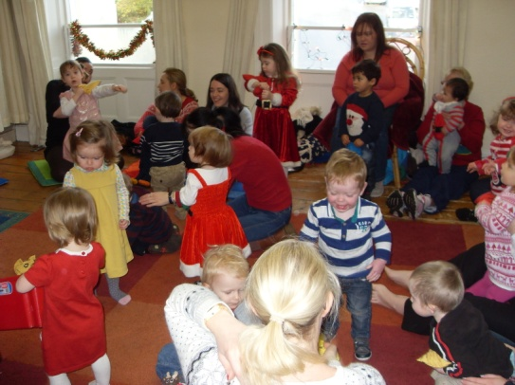
Associated with the drama group was the annual Christmas party with Santa and his helpers in December.
The ever popular parent and toddler group

The Monday Walking Group led by Alex Street continued into 2013. 12 adults accompanied by 2 toddlers in buggies availed of the support and companionship of other walkers over 33 weeks of the programme.

Sligo ETB provided a “My Baby and Me” development programme at the Centre for 5 weeks in the autumn with 18 parents and their babies/toddlers attending.
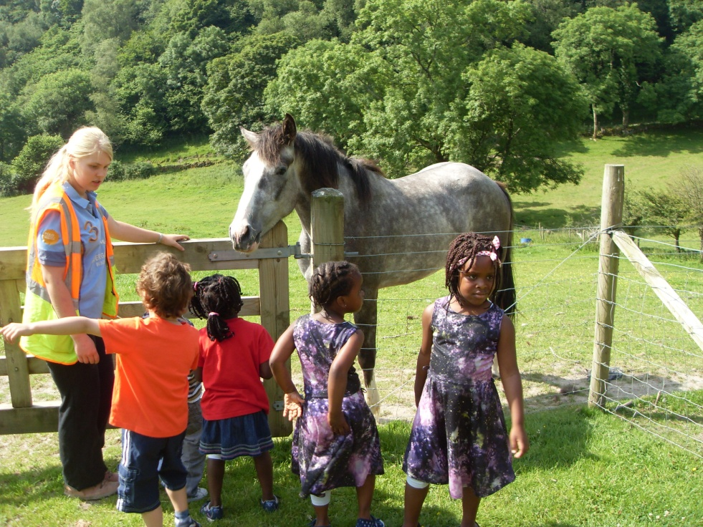
SMArt Art, an innovative stories, music and art for toddlers programme was rolled out in ? This encouraged participation, learning and fun for children preparing for pre-school. 24 parents/carers/grandparents accompanied 31 children to 12 sessions of this initiative.

The Adoptive Parents Group met five times at the Centre during 2013 and following the success of the Russian classes in 2011 these continued this year, with 13 classes on Russian language, customs and culture. They held their annual Summer and Christmas social gatherings in Merville Community Centre which was attended by up to 20 families. Sligo FRC co-ordinator continues to support this group.
Summer camp 2013

The Birth Parent Support Group met five times in 2013 at the Centre, facilitated by the Sligo FRC Co-ordinator. In October we invited Ruth Kelly, a social worker based in Wexford and author of 'Motherhood Silenced' a book about the experiences of natural mothers on being re-united with their adopted children. Ruth has worked in the areas of child protection, fostering and adoption for many years. New mothers continue to join this group which has been running now since 2005.
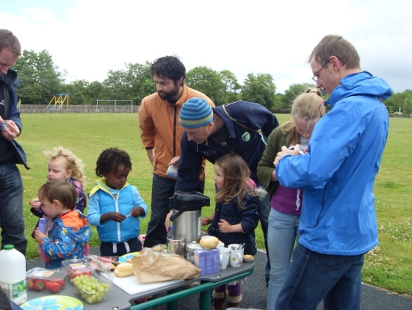
Father's and Children's workshop
In 2013, the IFI/U2 funded Music Generation initiative was rolled out in Sligo bringing music training to toddlers, pre-schoolers and primary and secondary school children. Sligo FRC benefited from 2 programmes which were run at the Centre by Giulia from Music Generation. This 5 week programme introduced toddlers and babies to the rudiments of music including rhythm, songs and rhymes and to a range of musical instruments. 21 parents and 27 children attended these sessions.

SmArt Art was continued into 2013 where we ran 2 six week sessions attended by 21 adults and 23 children. It was a combination of arts, crafts, music and story-telling.

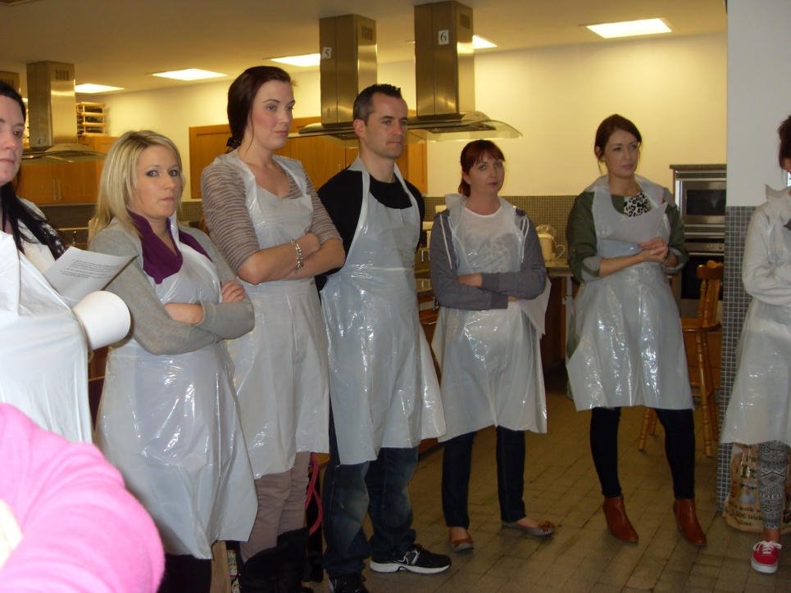
Over the year 14 women attended the Sewing/Upcycling Classes with Anne Culkin. This year we introduced a new class Cooking on an Budget with Household Management which was attended by 11 women. These classes were about developing skills among women of diverse backgrounds, from Globe House and Sligo’s settled community There was always a fantastic buzz and unbelievable productivity going at all these sessions. Both of these were funded by Sligo ETB.
Cookery course in St Angela's

Computers for Beginners was held in the FRC in the Autumn of 2013 with funding from the Sligo LEADER partnership through the Benefit4 Programme. 8 sessions took place and was attended by 24 adults.

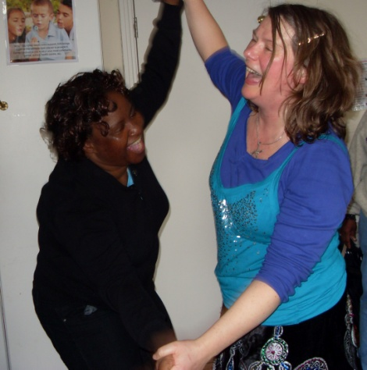
This year we did a treasure hunt for the Fathers and Kids Workshop in Doorley Park which was enjoyed by all.

We ran two Summer Camps during July for 20 children aged 4-6 years. The children were recruited from the Sligo community including Globe House, to facilitate integration during the programme. The children had a magnificent week of trips to Calry Pet Farm, the garda station, Fire Station, Doorly Park and Centre based activities including arts and crafts, messy play, face-painting and music and dance. This year we were extremely lucky with the weather and our biggest challenge was keeping the children cool and hydrated. The children made new friends and had a great time!
Laughter workshop to celebrate International Women's Day

We collaborated with a number of local agencies in 2012 to develop and lead initiatives in the Caltragh area of Sligo. The goal was to build on the success of the FRC’s Toddler Drama and engage other individuals from the area in community based activity and training. This development work included a new initiative in collaboration with St Angela’s college, Springboard Project and the Department of Social Protection. 11 participants took part in an 8 week programme in May and June of Healthy Cooking and Eating. It was co-ordinated by the FRC, funded by the DSP, transport provided by Springboard and facilitated by St Angela’s College.

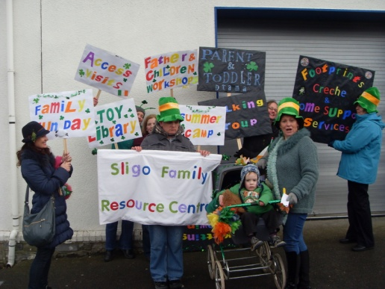
To celebrate International Women’s Day, 08 March 2013, we held a Laughter Workshop for women. It proved to be a real success with women from the area.
St. Patrick's Day Parade 2013
This year was our first time entering the St Patrick’s Day Parade. There was a flurry of activity for the weeks ahead of the parade pulling together our banners, posters and decorating prams and buggies.
Enjoying the summer picnic
We also had the usual Summer Picnic in the Mitchell Curley Park. This year we had better weather than previously. The children from Footprints, parents and kids from the Tuesday morning group enjoyed the event.
In May to mark the annual International Day of the Family, Sligo FRC hosted a family fun day with a European theme with funding from the Department of an Taoiseach. We had sean nós dancers, the mobile farm, Sligo Youth Theatre’s mad tea party and information provided by Sligo Co. Library.
We supported parents through the Strengthening Families Programme from January - March releasing two staff members to facilitate the parenting sessions once evening a week. We sought funding for the Parenting Plus Programme in collaboration with the 5 other FRCs and 2 Lifestart Programmes in Sligo / Leitrim. it was unsuccessful. We received €3,000 for parenting the 0-3 age group in partnership with Sligo CCC, Lifestart Sligo and Sligo Education Centre. The Incredible Years Programme is offered by the Sligo Education Centre and we have referred some parents to this.

WE supported par

Family Support Service Including Footprints Drop-in Crèche
The Family Support Service is provided in the homes of families in Sligo town and the surrounding county, as far as and including Co Leitrim. The length or extent of support depends on the needs of families, it can be a short time, e.g. helping a mum after the birth of a baby, or long term, eg supporting a family who are not coping due to bereavement, addiction or learning difficulties. Support is frequently provided in the form of parenting skills, budgeting, nutrition, childcare and homework support.

Three part-time Family Support Workers funded by the HSE and six of CE staff funded by the DSP supported 30 families in 2013. The Family Support Workers support families at all levels of the Hardiker scale while the CE participants support those at levels 1 and 2.

Referrals to the service were made by the Social Work Team in Sligo, Carrick on Shannon and Tubbercurry, social work adult with learning disability; public health nurses; Identification of Need (ION); Crib; Community Rehabilitation and Recovery Service; Autism Services; Early Intervention Team; Sligo General Hospital; HSE Psychology Dept; Molloway House; Citizen’s Information Service Tubbercurry; St Pat’s Hospital, Dublin; HSE Service Allocation Meetings (SAM) Foróige and Home Youth Liaison Service.

The Family Support service, including Footprints crèche (below) is funded by the HSE, Pobal, Dept of Social Protection and FSA.

Footprints Crèche is a service open to all families in Sligo and the surrounding area. Up until September 2013, it provided sessional care for children up to 6 years of age on a once off or continuous agreed basis to facilitate parents to attend appointments, training, counselling etc. In September with funding from Pobal we were able to relocate Footprints into a bigger room in the building next door. This enabled us to have 10 children at any one time.
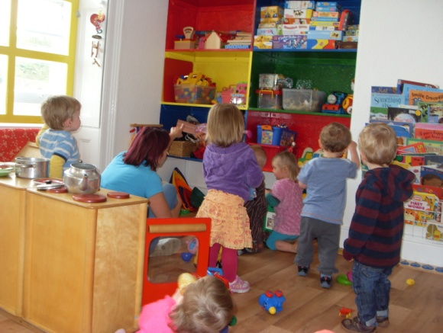
Last year 131 children from 103 families used the crèche. That is an average of 29 families per month. Of the children attending 74% were aged 2 and under. Of families attending, 75% were in receipt of a social welfare payment. Footprints has an exceptionally high staff:child ratio of 1:2/3 and is affordable with 3 bands of payment based on ability to pay
Staff have built strong links over the years with key referral agencies to ensure families with particular needs can access the crèche service. In 2013, 34 children in need were referred to Footprints from 32 children were referred by local agencies including: Social Work Teams; PHNs; Lifestart; VEC; DVAS; counsellor for special needs; SW for adults with learning disabilities and the HSE Early Intervention Team.
Footprints crèche moves to a bigger room

Services to Adult with a Learning Disability
Staff are managed by the co-ordinator of this service, Fiona Brennan on a part-time basis. With an increase in her workload her hours were increased from 1 day/week to 2 days/week in September 2013. We now have five support workers, one works 20 hours/week; one 10 hours/week 1 six hours/week and 2 five hours/week. In addition a new initiative began in July 2013 where we introduced a drop-in session every Thursday at lunchtime – this is managed by 2 support workers doing 2.5 hours/week each. Within this aspect of the service 3 people receive one-to-one support and up to six attend the drop-in Thursday club.

In 2012, Sligo FRC took on the operation of the Coffee Dock café based at Markievicz House, providing training opportunities in a social enterprise for adults with a learning disability. This is running successfully and last year accommodated 11 trainees.

Working with Cultural Minorities
The Integration and mentoring project was established in late Autumn 2012. The Integration aspect was funded by PEACE III through Sligo/Leader Partnership and the mentoring by National Lottery. The purpose of the integration strand was to provide direct support to those leaving Globe House who have leave to remain/refugee status in Ireland and who are now settling into living in the Sligo community. The second strand involved the training of local community volunteers to mentor people who currently live in Globe House. Working 5 hours/week on the Project Catherine McGlinchey the co-ordinator of this Project was able to directly support 13 people who left Globe House (some of whom had children) and 8 volunteers and 8 mentees in the Mentoring aspect of the Project. An evaluation of the Integration strand of this Project can be read on the Sligo FRC website www.sligofamilyresourcecentre.org
Sligo FRC was actively involved in the work of Diversity Sligo. We co-ordinated the physical activity programme for women one morning a week, the bi-monthly newsletter, were secretary to Diversity Sligo group, and sought funding for this group.

Racist Indecent Reporting and Support Service
This was established in 2013 with funding from PEACE III. Deo Ladislas Ndakergerwa was appointed project co-ordinator in June 2013 to establish the service and to set up an Intercultural Forum for Sligo. The Project was well supported by other agencies in Sligo including the HSE, Gardaí, ETB, Sligo Education Centre, Sligo Borough Council, Sligo IT, Sligo General Hospital, Domestic Violence Advocacy Service, Sligo Rape Crisis Centre, Lifestart Sligo, Sligo Social Services, Sligo LEADER Partnership, Diversity Sligo, Aremoja, Sligo/Leitrim Filipino Association, Sligo Kurdish Community, Sligo Travellers Support Group. Out of this an Interagency group was established who met six times over the six months, there were 2 cross border visits: Belfast and Dungannon, three evening training sessions with people from intercultural backgrounds, 3 road-shows, launch and closing ceremony which attracted over 70 people at each event as well as several newspapers articles and radio interviews. By the end o f2013, 23 racist incidents were reported and followed up, the Service was up and running and the Sligo Intercultural Forum was launched in November with a preliminary steering committee/board of management.
Launch of the Racist Incident Reporting and Support Service

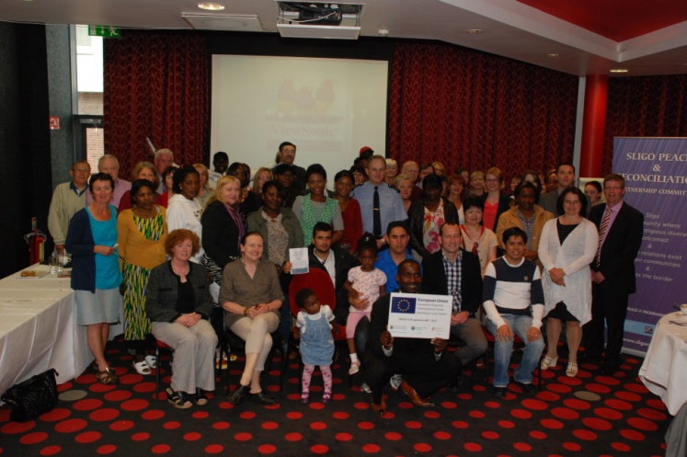
Representation and Inter-agency Initiatives
Sligo FRC is represented on a range of committees and boards in Sligo in order to represent the needs of the families we serve and to bring about policy and practice changes which we hope will improve the lives of families. Some of this work involves presenting views and developing policies, at other times it involves creating new joint projects and initiatives.
During 2013 we were involved in the following committees/groups:

Local Organisations
- Sligo/Leitrim Children and Families Committee
- Sligo County Childcare Committee
- FRC Administrators’ Regional Network
- Social Inclusion Measures Group
- Diversity Sligo
- Sligo Men’s Network
- HSE Service Allocation Meetings
- Education Working Group
- Caltragh Working Group
- Training Links
- Sligo Integration working group
Regional Organisations
- FRC Regional Network
- FRC National Forum
- FRC Administrators Network
- FRC Co-ordinators’ Regional Network

Voluntary Board of Directors and Staff Team
Sligo FRC is managed by a voluntary board of directors who oversee the work of the Centre and strategically guide the services. A number of full and part-time staff are employed to manage and implement the work and ensure services are provided to the highest standard. Sixteen staff are employed through a CE training scheme.

Chairperson: Martina Kilgallon
Vice Chairperson: Ruth Campbell
Treasurer: Lucia Macari
Secretary: Sonya Coffey
Directors: Deirdre Gaule Pauric Cuffe, and Mary Waters Chris Davis, Bernie Davey, Nike Ogun, Don Watts,

The management committee comprised 12 volunteers in 2013. The executive sub-group meets for employment/staff matters or specific issues. Sub-groups of 2-3 board members are established for specific, short term pieces of work in order to share the load and they’ve proved to be effective

Staff Team
Elizabeth King Co-ordinator (job sharing)
Catherine McGlinchey Co-ordinator (job sharing) and Mentoring support worker (5 hours/week)
Cathy McGowan Administrator
Charlotte Bussmann Family Support Childcare Co-coordinator
Bridie Walsh FÁS Supervisor (job sharing)
Sarah Cleasby FÁS Supervisor (job sharing)
Rose McCrann Footprints Crèche Supervisor
Fiona Brennan Coordinator of Services for Adults with Learning Disabilities (14 hours/week)
Deo Ladislas Ndakenergwa Co-ordinator Racist Incidents Reporting and Support Service
Sue Coleman Home support Worker (25 hrs/week)
Colette Sheerin Home support Worker (20 hrs/week)
Karen Casey Home support Worker (10 hrs/week) and Coffee Dock supervisor (10 hours/week)
Ann Boyd Social Club Leader (7.5 hrs/week)
Maureen Scanlon Social Club Leader (5 hrs/week)
Amy Gerrity Transition Support Worker (20 hrs/week)
Ann McPadden Support Worker (6 hrs/week)
Esther Mooney Support Worker (12.5 hours/week)
Marion Roycroft Coffee Dock supervisor (25 hours/week)

Students:
Maria Moore was a student on placement for 12 weeks from Athlone IT studying Social Care.

FÁS Community Employment Scheme Participants (2012/2013), 19.5hrs/week
Administration and Reception | Alex Streete  Eileen Sheridan  Joanne Kelly  Geraldine Moran
Childcare and Home Support Workers | Maureen Scanlon  Anita Murrin
Caretaker/Cleaner | John McLoughlin

Five childcare CE staff were moved from being employed by Sligo FRC to the employment of the Sligo County Childcare Company Ltd. in December 2013.
Training undertaken by staff

Training undertaken by all staff included:

CE participants induction  Occupational First Aid  Paediatric First Aid  Child Development  Children with additional needs  Children First Child Protection  Special Needs Assistance  Manual Handling  Early Childhood Education  Work experience  Workplace Food Safety and Hygiene  Train the trainer  Medical Secretary  Facebook for Business Beginners  Information Technology  Being Connected Computer Training  working with adults with learning disabilities  Speech and language for children with autism  CE participants induction  Occupational First Aid  Paediatric First Aid  Child Development  Children with additional needs | Manual Handling  Early Childhood Education  Work experience  Workplace Food Safety and Hygiene  Train the trainer  Medical Secretary  Facebook for Business Beginners  Information Technology  Being Connected Computer Training  working with adults with learning disabilities  Speech and language for children with autism  Basic IT  summer camp training  Healthcare  parenting programme  Brief intervention training  Síolta Standards  Numeracy and literacy skills  cyber bullying  motivational interview training  grief and bereavement in the workplace  refresher first aid  Children First Child Protection  Special Needs Assistance

Sourcing Funding
AS can be seen by the number of application for funding submitted an enormous amount of time is dedicated to sourcing funding each year - not all of it successful.
Community Employment Scheme for 2013-2014 – 16 staff (successful)
Community employment Scheme 2013/14 with additional 3 places – (pending)
Community Food Initiative Programme in collaboration with St Angela’s College (unsuccessful)
Capital funding to PEACE III Programme: January 2013 (unsuccessful)
Tender for the Racist Incident Referral and Support Service to PEACE III in March 2013 - €45,000 (successful)
Childcare Capital Programme 2013 to upgrade the heating system - €4,900 (successful)
Grassroots Equipment Grant from Community Foundation of Ireland - €1,000 for the FRC and €1,000 for Diversity Sligo (successful)
Department of the Taoiseach’s Communicating Europe Initiative (CEI) -€1,000 (successful)
AIB Get Ireland Growing Fund (unsuccessful)
Lottery Application Sligo Leitrim West Cavan for the recreational room - €3,800 (successful)
Lottery Application Sligo Leitrim West Cavan for the mentoring project -€2,000 (successful)
VEC tutoring - 40 hours (successful)
VEC Family Support - 60 hours (successful)
County Childcare Committee for summercamps - €400 (successful)
Department of Social Protection Proposal for funding under the Activation and Family Support Programme (AFSP) - €3,500 (successful)
PEACE III funding through Sligo LEADER Partnership for the Integration Project - €3,956 (successful)
Katherine Howard Foundation in collaboration with Lifestart Sligo, Sligo County Childcare Committee and Sligo Education Centre (€3,000 successful)
Parenting Plus in collaboration with the five other FRCs in Sligo/ Leitrim (unsuccessful)
European Integration Fund (€78,000 unsuccessful)
Comparative figures of service users from 2013 are about the same as 2012 despite the substantial cuts to funding from all our major funders (i.e. FSA, HSE and DSP). There were some new initiatives including the Integration Project, the Mentoring Project, the Racist Incident Recording and Support Service and the Thursday lunchtime social club.

