Final Report
of the Sligo Family Resource Centre
Integration Project 2012/13

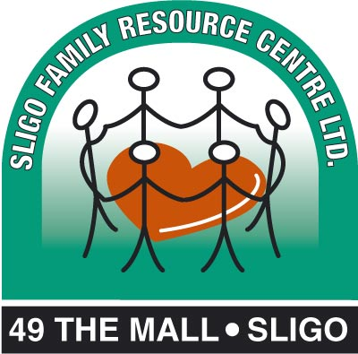

Catherine McGlinchey, MSc
Project Co-ordinator

15th November 2013

This project has been funded by the PEACE III Programme through the European Union’s European Regional Development Fund managed for the Special EU Programmes Body by Sligo County Council on behalf of Sligo Peace & Reconciliation Partnership Committee
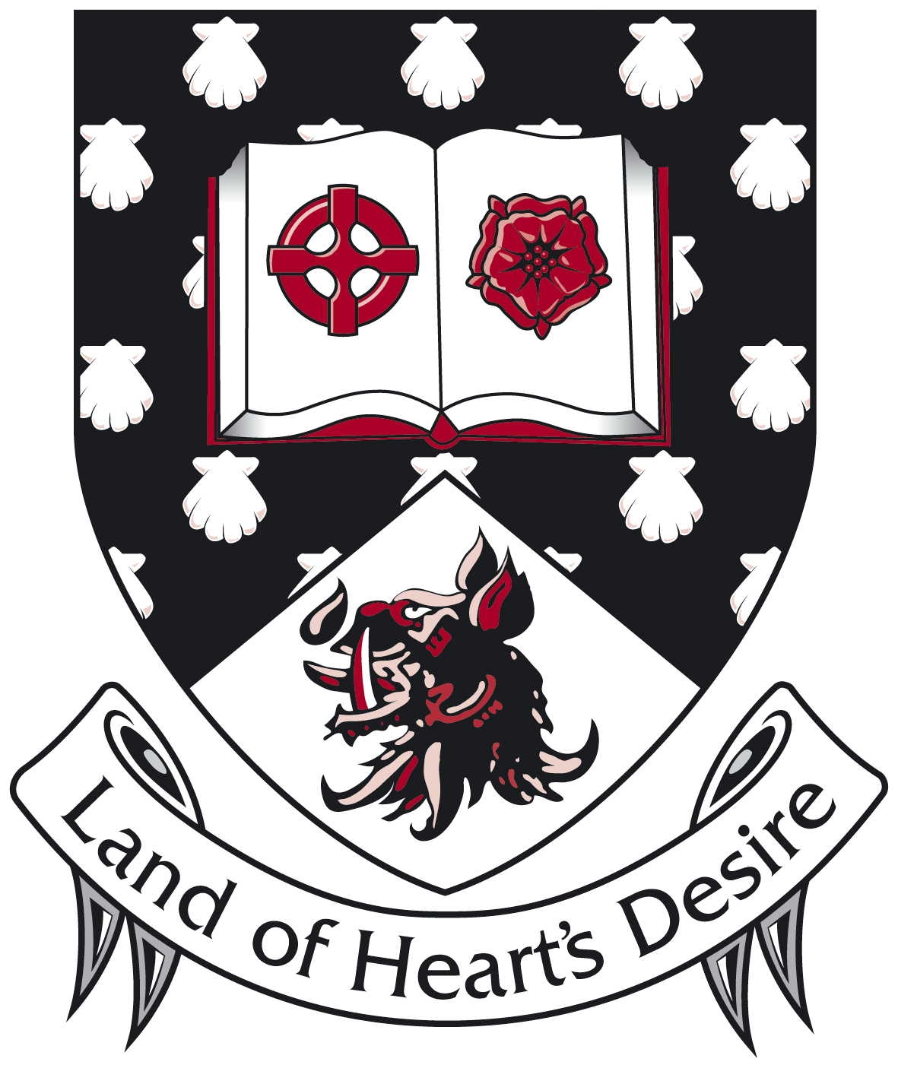
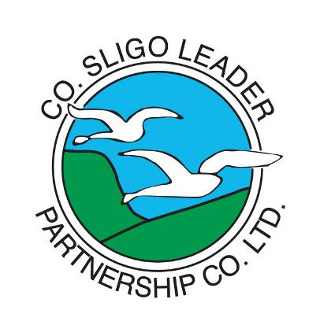

Introduction
The Sligo FRC Integration Project was established in October 2012, as a result of an identified need in the community. This need was to assist asylum seekers who had received their papers, with their transition from Globe House direct provision facilities to living in the Sligo community. Under Peace III, funding was made available to Sligo Leader Partnership to run this service. Sligo FRC was awarded the tender to employ a part-time (3 hours/week) staff member to co-ordinate the service over one year.

Aims and Objectives
The aim of the project was to support asylum seekers in making the transition from Globe House to living in the community, whatever their status, whether refugee, persons given Leave to Remain Subsidiary Protection or persons given residency on the basis of being a parent. The objectives were:
- To set targets for the programme in conjunction with Sligo FRC, Diversity Sligo and Sligo LEADER Partnership.
- To provide clients with advice, support, information and practical assistance.
- To advocate on behalf of the clients.
- To liaise with relevant organisations regarding the programme.
- To report to the Integration Steering Group at least every quarter and write updates for the Sligo FRC, Sligo Leader Partnership, Diversity Sligo and Peace III.
- To review and evaluate progress.

Project Implementation
The project began at the end of October 2012 when two clients who had received their papers needed immediate assistance in their transition from Globe house into the community. Over the period of a year, 12 clients were assisted to varying degrees, all of whom had received their papers and were eligible to move from Globe House into the community. The project was managed by Sligo FRC and overseen by a Steering Committee from the three key agencies, namely Sligo FRC, Diversity Sligo and Sligo Leader Partnership, through quarterly meetings and reports.

At the start of the project, a meeting took place with the Managers of Maryville Hostel operated by Sligo Social Services to achieve co-operation and prevent duplication by the project of their services in the resettlement process. It was agreed that when successful asylum seeker/refugee clients from Globe House availed of Maryville's supports, the Integration Project would focus on social integration, home and life management, documentation and support not being met already by Maryville.

The project was driven by the needs of clients, so any actions during the project were a response to specific queries, information gaps, financial issues, practical problems and emotional issues that were making life difficult for the clients as they transitioned into the community. Every client met for an initial meeting and the response depended on the needs expressed from this and subsequent meetings.

Actions
Four clients attended an initial meeting regarding their move from Globe House. They received information on key elements of moving into the community, e.g. securing welfare payments, seeking employment and accommodation, banking and other relevant support services. They received follow-up phone-calls but required no further direct assistance from the project, as one soon moved away from Sligo to live elsewhere, the second had the supports and contacts needed to get on, the third was already in a stable set-up when he made contact with the project and had sought specific information, which was provided. The fourth had not received their papers, as originally thought.

A client with two young children received support in household management, dealing with various agencies and budgeting/shopping on a budget, as well as how to connect with neighbours and the local school. This family was also supported by other services, so the Co-ordinator attended inter-agency meetings on the family's progress settling in.

Assistance with family reunification was the focus of support given to a male client living alone, as well as advocacy in relation to an application for disability allowance. This process proved to be long and difficult as it took time to compile the required information and documents and it was an emotional journey for him too, as he had had no-one except a lawyer prior to this to share his circumstances and difficulties with. His completed family reunification papers have been submitted and he awaits a response.

Practical assistance was provided to a separated male client supporting his young daughter in co-operation with the child's mother. Household and budgeting skills were the main focus, as well as emotional support while he got established in an apartment. He was also extensively supported by Sligo Social Services and, following a referral from this project, MABS.

A female client living alone received emotional support and practical help in securing accommodation and then moving from one flat to another. While already skilled in budgeting and household management, she benefitted from additional tips and advice around making her money go further and securing support from the relevant agencies regarding her efforts to get back to education, as well as acquiring a computer for her studies. She successfully achieved all this. Emotional and informational support continued until the end of the project.

Another female client living alone benefitted from the project through support in getting set up in an apartment, budgeting and household management skills, as well as support completing family reunification documents. This support continued to the end of the project. As she was also receiving help from Maryville, co-operation to avoid duplication of services was a key part of this support.

A male client living alone was assisted in securing RAS accommodation in co-operation with Maryville Hostel staff who again were also assisting the client. Practical guidance on managing an apartment was provided as well as budgeting and cooking tips. Emotional support and where possible, practical assistance was given in his efforts to get back to formal education in another county. This proved to be a challenge as there is no clear agreements between counties regarding transfers of benefits and allowances to support somebody seeking to move. This was eventually achieved and emotional support by phone continued to the end of the project.

Assistance was provided to a single male client in securing documents relating to conditions of his stay here in Ireland as well as help finding an apartment. Due to administrative issues relating to his London-based embassy, he received advocacy support as well as TD lobbying to formalise his status.

Finally, intensive support was provided to a female client and her two young children in securing accommodation, documentation and welfare entitlements during the last three months to the end of the project. In addition, budgeting and practical assistance was provided regarding her home and a referral made to Sligo FRC Family Support Project to ensure extra support in managing the children. Literacy issues and the client's need for emotional support in getting established in the community dictated the intense level of support provided.

A key aspect of the project's work was to liaise with other relevant agencies, where appropriate. The following agencies were contacted during the course of the project: Sligo Leader Partnership, Diversity Sligo, Sligo Social Services and Maryville, Sligo Co Co Housing Section, Intreo, HSE Social Work Dept, Gardai, Schools, MABs, Simon Community, Sligo Credit Union, Globe House, Simon Community, Solicitors, VEC, Cranmore Co-op, Avalon Centre, Dept Social Protection Disability Allowance Section.

In addition to the direct work with clients, the Co-ordinator and a client also attended two meetings to contribute to Sligo's Integration Plan; two clients were facilitated to write about their experience of the project under the Making Peace Public initiative; and one of the families were brought along to participate in the closing ceremony of the overall Peace III Programme at the Sligo Park Hotel.

Aspects of the Project that Worked well
Seven of the eleven clients completed an evaluation questionnaire based on the support they received through this intervention. Their responses as well as observations made by the Co-ordinator and Steering Committee are presented here:
- The project was led by the clients and their stated needs for information or services were met through practical assistance, contacts, emotional support and information. Those who participated were keen to get the help;
- Clients had phone access to the Co-ordinator at all times and could ring freely when issues arose. They were very happy with the flexibility of the service;
- Some key "connectors" were provided to each client, e.g. groups in the community relating to their interests, services they needed to be aware of for support (e.g. Sligo FRC, Sligo Leader, Social Services, Intreo office, Housing Office, Simon Community Tenancy services, Sligo Credit Union etc) and these may prove useful in the future, if not needed immediately;
- Occasionally the Co-ordinator observed needs that the client may not have been aware of and provided information and guidance around these, (e.g. opening a credit union account, tips on managing the house, where to shop for cheap clothes/food etc);
- Clients were comfortable attending meetings at Sligo FRC and they were happy to receive help in their homes when needed;
- In general, clients all felt the assistance was relevant, well-prepared in so far as possible, or researched/responded to if information wasn't available at the time of a request;
- Clients were happy with the intervention methods and working environment and it made them think about what they were trying to achieve;
- They agreed or strongly agreed that they were more aware of services and supports in Ireland, the practicalities of living here and improved skills in home management as a result of the project;
- They all reported that they would recommend the service to somebody else who was leaving Globe House and moving into the community.

Some key observations reported by individual clients included:
- I appreciated the kindness shown to me through the project;
- I learned that honesty works in seeking help and people appreciate honesty;
- I would recommend Maryville Hostel and the Social Services supports;
- I would not have known how to deal with things before this intervention, or about the range of services in Ireland;
- I learned how to connect with services and how to economise;
- Learning about where to go for help and where to get what you want was most useful;
- I recommend the programme continues but with more hours available for support and possibly a permanent post for the facilitator;
- All efforts were good;
- Staff good - the learning of knowledge and experience is good;
- I already had good skills and know how agencies worked but I got good support which made me think and everything was ok with the intervention.

With regard to Peace-Building, clients reported the following change in their thinking:
- This intervention has helped peace building;
- If you are open to people, people will be open to you and will make friends;
- If you need help, look for it;
- I feel more confident living alongside people in the community regardless of race, colour or religion;
- Personal connections can help speed up processes;
- Regarding Asylum, there are no coherent connections between counties;
- I sense that despite our differences we are all members of the same community;
- There is extra relations with people as a result [of this project];
- Yes, I'm happy, you are now my friend and everything worked out;
- Its for my children that I do everything, they are what count.

Difficulties Arising in the Project

When funding for this project was secured, it was anticipated that a small number of people would secure papers to remain in Sligo over the course of the year and that the allocation of hours (3/week) would be adequate. In fact over 12 people received their papers during the twelve months and the 3 hours/week was inadequate to meet the demand for support. In September additional hours were sought to meet the high demand for the service and an extra block of funding allowed the Co-ordinator to work intensively with a family of a mother and her two children who needed extra help at that time. A more comprehensive programme of support could have been delivered if more hours were available, in terms of the frequency of contact and follow-up with clients.

It is challenging for a worker to be available for support via phone or appointment at any time and this would have to be addressed in any future service of this nature.

Learning from the Project
The clients of this project have expressed how challenging the change is in moving from Globe House into the community. In the majority of situations clients were initially exhilarated and joyful that they had finally got a positive decision on their asylum search. This soon turned into stress and pressure when they had to achieve so much in so little time with so little financial resources or knowledge about what is involved in trying to get accommodation and money sorted out, in addition to other aspects of living in the community. This stress was particularly intense for the two women who had children to look after too. For some, they have found living in the community lonely and while they are aware of opportunities to get involved, for some they simply long for their families to be reunited with them in Ireland before they feel they can integrate properly.

Clients have indicated that much of their information about services and opportunities in the community comes from other asylum seekers in their networks. The Community Welfare Officer at Globe House is a key source of information for some. They also seek help from volunteers visiting Globe House, Sligo Leader Partnership, Sligo Social Services, Maryville Hostel, St Vincent De Paul and Sligo Citizens Information Centre as well as Sligo FRC. They all engaged with Intreo and Sligo County Council Housing Office where they were helped, though each found the paperwork overwhelming in terms of getting entitlements sorted.

Each client had differing positive views and issues on living in the community, but the following list illustrates the typical ones communicated during the support sessions:

Positive Aspects of Their Move into the Community, in Clients' View
- New freedom to travel abroad;
- Freedom to make plans to see family members;
- Getting support from various agencies, not feeling alone;
- Finally being free from Globe House;
- Experience of a fair/helpful landlord;
- Maintaining friendships in a church community;
- Getting help from friends in the community and in projects where participants have volunteered (utilising informal networks);
- Getting particularly good support from Maryville Hostel on a range of issues and the Co Council Housing Office regarding housing;
- Getting to know neighbours in the community;
- Accessing part-time paid work now rather than always having to only volunteer;
- Children doing well in the community and at school;
- Ongoing contact with family;
- Realising that relative to their own country, services here are efficient and timely;
- Two clients were able to make plans and arrangements to visit loved ones in Africa whom they have not seen for years.
- Discretionary welfare payments are being made through the community welfare officer while clients await completion of paperwork for registered welfare, so they have some income in the interim;
- Two clients feel connected with home via internet and foreign news links online, though it makes them sad to see what is happening in their home country;
- Making progress on achieving plans, e.g. successful interviews/exams etc;
- Two clients who had visited loved ones in the summer/autumn returned to Sligo feeling renewed and reconnected with their families;
- Two clients started attending third level education and despite the cost they are working hard and achieving their goals;
- Realising that honesty is the best policy in seeking and getting help;
- Changing from a period of stress to feeling in control of life again;
- Finding friendship with people who don't live in Globe House;
- Getting the opportunity to live independently again and get into further education.

Issues Arising for Clients' Moving into the Community, in Their View
- Budgeting issues and managing to pay bills on a limited budget;
- Lack of/lost cooking skills and a need for training in preparing meals on a budget;
- Adjusting to free time (sometimes lonely) in the evenings when living independently;
- Being sent from pillar to post with paper-work when trying to get welfare payments sorted out and feeling frustrated;
- Feeling stupid about not being able to manage sometimes;
- Being uninformed about services such as the credit union, bank Direct Debit payment systems; cost of services such as TV/Internet; social services clothes shops, bargain foods at the supermarket;
- Loneliness and sometimes relying still on friends from Globe House for company and contact;
- Not having as much freedom living in the community as in Globe House as now don’t have anyone to mind the children to allow a parental break;
- Cooking for one and eating alone;
- Spiralling debt and ongoing budgeting issues;
- Not always trusting one’s own judgement.
- Noise of traffic and car racers outside disrupting a peaceful existence in a new apartment;
- Things not working at an apartment but landlord not willing to carry out repairs he/she is responsible for;
- Not being able to travel as a family due to documentation issues with one dependent member of the family;
- Cost of documentation, e.g. GNIB card - where can the money for this be saved on €19.10 per week?;
- Issues arising in a bedsit with shared washing/toilet facilities, it required a house move to feel safe again;
- Security issues in houses, e.g. back door locks were faulty and insecure, leaving the female tenants vulnerable - it took repeated pressure on the agent/landlords to fix them;
- Avoiding meals to save money for other things and not wanting to eat alone;
- Complex family issues making reunification with family members complicated;
- Difficulties opening accounts etc without a fixed address, but needing an account immediately to pay for electricity etc when accommodation is found;
- In trying to move from one county to another, there is no system of co-operation between agencies, and frontline staff don't really know how things work in other counties, its not uniform.
- Overwhelmed by all that needed to be done in settling into the community. "How am I supposed to know this?" was one client's mantra with regard to the many issues arising for her;
- Worries about what is happening to their families due to awareness of political situations through the internet;
- Frustration and stress at things not working out.

Additional Issues facing Clients Observed by the Project Co-ordinator
- Being unrealistic regarding future plans, e.g. hoping to start a new business without required knowledge or training for Irish setting;
- Poor literacy skills negatively impacts on clients settling into the community due to the extensive form-filling, document requirements and phone-calls/meetings needed to get everything sorted out;
- Where a client has a lack of documentation e.g. birth certs or passport/national identity card, finding compensatory ways of dealing with this and the related cost is difficult, time consuming and expensive for clients;
- Some staff working in agencies or businesses found it difficult to understand what the clients were saying which eroded their confidence in terms of dealing with staff or talking on the phone;
- For some asylum seekers who have connections elsewhere, they will move away from Sligo even though they are unsupported and will face many obstacles;
- Clients who worked extremely hard to get placed at third level are discovering how challenging the costs associated with going to college are when living on social welfare and having no family support;
- Clients sometimes need counselling to assist them to come to terms with their life situation and the background issues causing them stress as they try to build a new life, but they are unaware of how to go about seeking this kind of help;
- Electricity readings/ first bills are an issue for clients, with three on this programme probably inheriting electricity costs from previous tenants of their rented apartments. Landlord/agents delay giving the clients a meter reading when they move in and the first bill in each case was well over and above what would be expected based on usage and the short billing period. This puts clients in a vulnerable position as they are immediately in debt to the electricity company on receipt of the first bill. Additionally they are more inclined to change to the expensive Pre-Pay system.

Recommendations based on the Learning from this Project

- A dedicated part-time information/support officer should be made available to all asylum seekers from Globe House who receive their papers, to assist them in the transition process to living in the community. This could be an additional part of services provided by other agencies currently providing supports in Sligo, or a dedicated service continued by the Sligo Family Resource Centre.

- Direct provision should be reformed to ensures asylum seekers retain as much of their independence and enabled to live as independently as possible. Reforms such as the reintroduction of child benefit improving their welfare payments in line with inflation and providing improved self-catering options would facilitate this, as would, (as in other European countries), allowing asylum seekers to work or train to retain or improve skills. Under the current regime, asylum seekers are severely disadvantaged financially and skills-wise when they embark on a new life as an Irish citizen. If they had improved resources to engage in the community and retain or learn skills, most of the integration this project was trying to assist with will already have been achieved.

- The decision by Sligo County Council to no longer provide Sligo Social Services with deposits for people in need of them when they seek accommodation on leaving Globe House should be reversed, as it immediately puts individuals in a position of homelessness for the period until they have an address in order to gain welfare entitlements.

- The learning from this project should be disseminated to relevant agencies, to assist in the planning and development of services to help our growing new communities integrate into Sligo life.

Publicity

The following Press Release was submitted to Making Peace Public following consultation with the two clients interviewed.

PRESS RELEASE

New Community Members Find their Feet with Independent Living in Sligo
Sligo Family Resource Centre supports asylum seekers in Sligo who have been granted leave to remain in Ireland and who move from Globe House to live as full members of the Sligo community. For many asylum seekers, the decision to be granted this opportunity to live in Sligo is one they have waited years for, having lived in the meantime in shared hostel style accommodation provided at Globe House. Once a positive decision is communicated by the Minister for Justice and Equality, an asylum seeker must very quickly meet the challenge of living independently, often alone and frequently on a low income until they get on their feet. Any new member of the community from Globe House will be helped in this process by a range of agencies including Sligo Family Resource Centre, Sligo Co Council, Dept of Social Protection, Sligo Leader, Sligo Social Services, Diversity Sligo, Citizen’s Information, churches and many other informal networks.
Catherine McGlinchey, Co-ordinator of the Sligo FRC Integration Project said, “it can be an enormous challenge for someone to move from the protection of Globe House with its limited opportunities for people to study, cook ethnic food, socialise in the community and no opportunity to work, to a new situation where they must secure accommodation, budget for living expenses and find new work/training opportunities. As one person who benefitted from the project said, ‘it can be tough to jump out of the nest and learn to fly again, even though it is what you desire’. During the nine months of this project, I have witnessed and supported eight individuals who have shown strength and determination in finding their wings and establishing themselves as full members of the Sligo community.”
Shupai Matewa succeeded in her asylum application to remain in Ireland in 2012 and as a skilled and experienced community and church leader, soon realised her dream to go back to further third level studies at Sligo IT. Shupai said, “This project made a great difference to me. There was a need to have someone to help me along as I integrated into the Sligo community. When in Globe House you feel totally cut off from the reality of living outside it and former residents need help to adjust and feel part and parcel of the community. The information and support I got was readily available and very reliable.”
Another participant of the project, Robert Olama also realised his dream of further third level studies. He was accepted at University College Cork where he will study and train to be a social worker. For Robert, the main benefits of his links with Sligo FRC Integration Project was to manage an apartment, budgeting, cooking, getting onto various courses and information on activities in the community. Robert said, “I nearly collapsed when I received my first electricity bill which was huge. I struggled to pay it at the time as I was on a tight budget, but with information and support I was able to reduce my second bill by 75%. In my view the project should be extended time-wise so that people can have greater access to support.”
Catherine highlighted that one of the key issues facing former residents of Globe House as they integrate, is navigating the maze of agencies that must be dealt with to become established in the community. Helpful, informative staff in the various offices has a really positive impact on their confidence and understanding of what they must do to live independently. It is also critical to building positive community relations.
Sligo FRC’s Integration Project has been funded by the PEACE III Programme through the European Union’s European Regional Development Fund managed for the Special EU programmes body by Sligo Co Council on behalf of Sligo Peace and Reconciliation Partnership Committee.
…/end

Newspaper article and Photo appeared in the Sligo Champion
as a result of the Press Release Submission, featuring one of the clients involved in the project.

