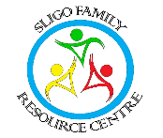
Sligo Family Resource Centre
49, The Mall, Sligo. F91HR58 -Tel: 0719146315 / 0873395469
email: icwsligofrc@gmail.com
_______________________________________________________

English Classes Registration Form
Name
Address
Mobile number
Email address

What do you think your current level of English is?
Beginner (has a few words of English). Beginner (can hold a conversation)

Intermediate Advanced

Why do you want to take English classes?

For work For study For communication

Would you like to be contacted by Sligo FRC for other programmes, events or information?

Yes No

Do you agree to your photo being taken for Sligo FRC publicity on social media, funder’s report and Sligo FRC annual report, Sligo FRC website?

Yes No .

Please Sign: _______________________________________ Date: _______________________

In order to be compliant with the Data Protection Act 1998 & 2018, we may collect and store information gathered in order to manage, track, increase and improve our service to you. We respect your right to privacy and will not disclose this information to third parties unless we are required to do so legally.
